**Institute of Computer Technology  
B. Tech. Computer Science and Engineering  
Sub: ESFP – I  
Assignment-1**

**Name:-Dwij desai Roll no.BDA08 class:-B Batch:- BDA**

**1.** What are Tokens? Explain various kinds of tokens in the C programming language?

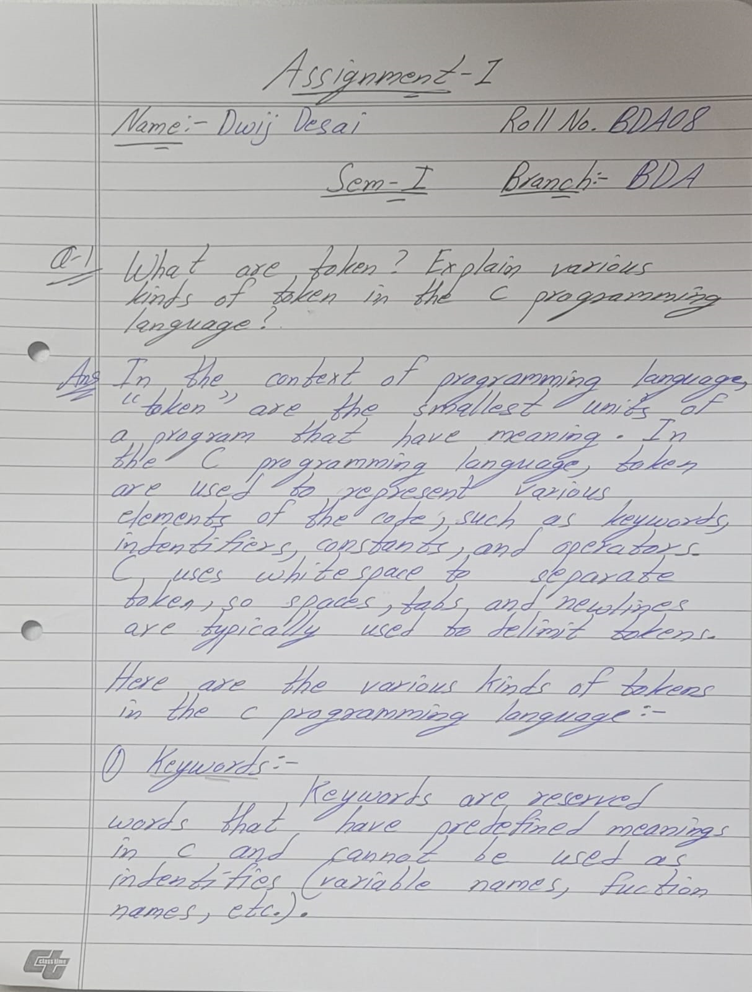

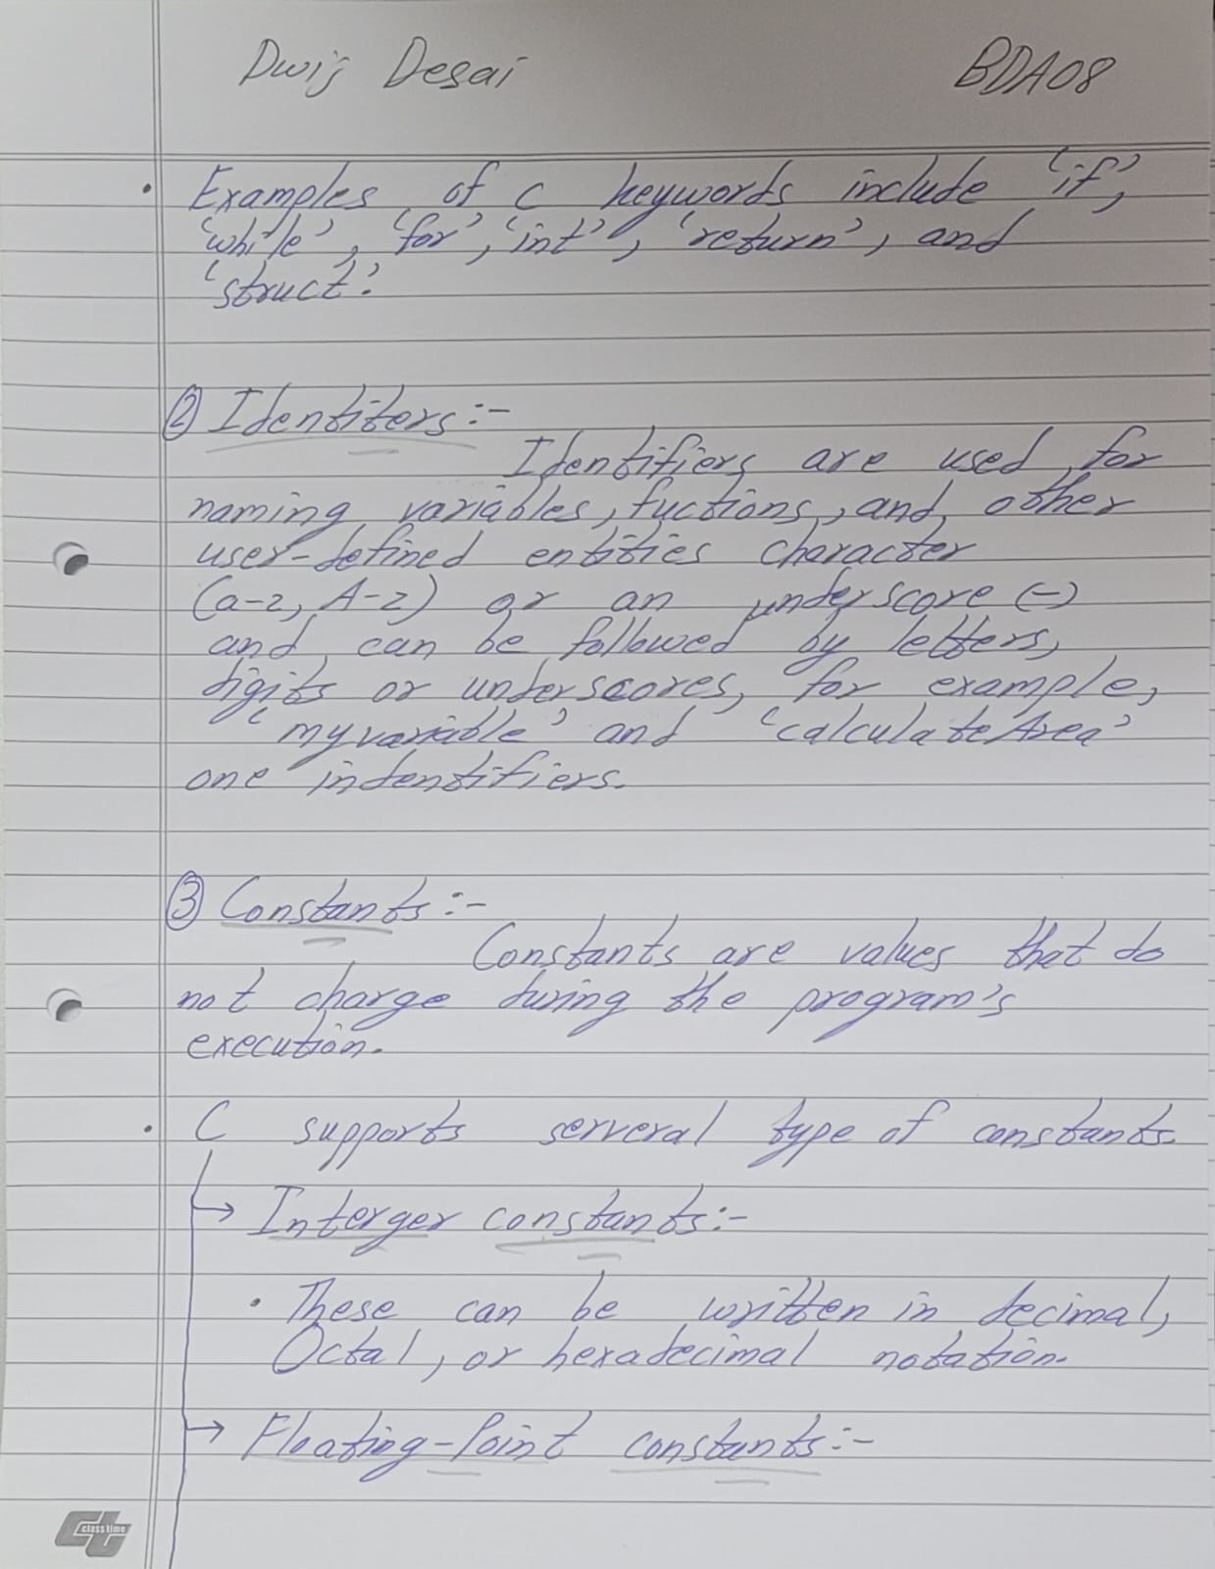

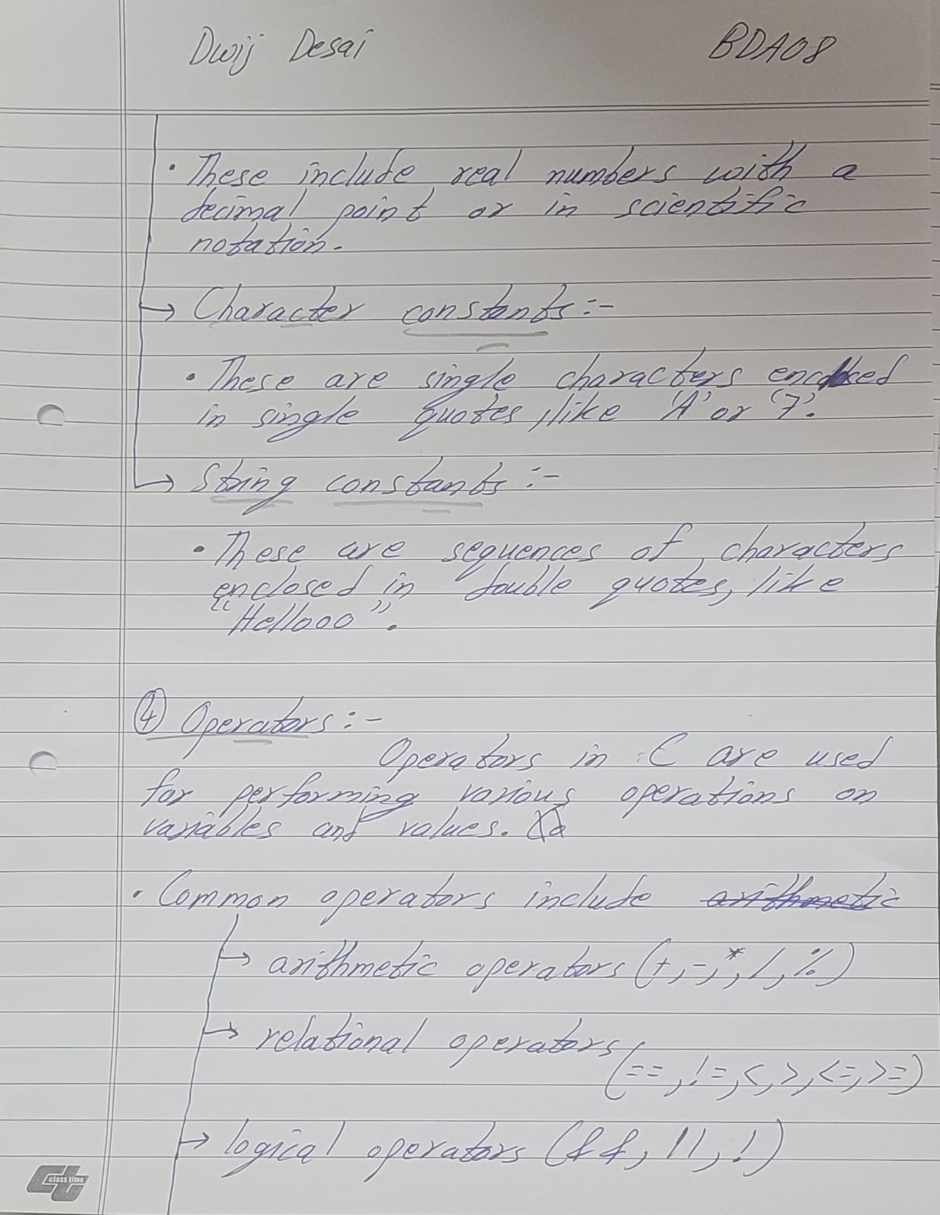

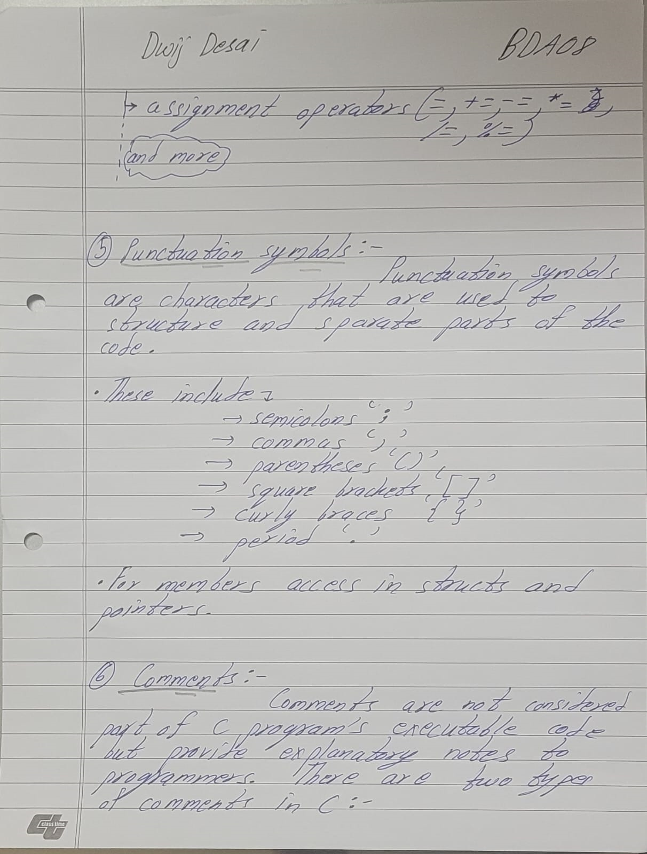

Here's an example of a simple C program with various tokens:

#include <stdio.h>

int main() {

    // This is a single-line comment

    int num1 = 10;        // Variable declaration and assignment

    int num2 = 20;

    if (num1 < num2) {     // Conditional statement

        printf("num1 is less than num2\n");

    } else {

        printf("num1 is greater than or equal to num2\n");

    }

    return 0;

}

**Question – 2:**

Explain the differences between compile time and run time errors with the help examples?

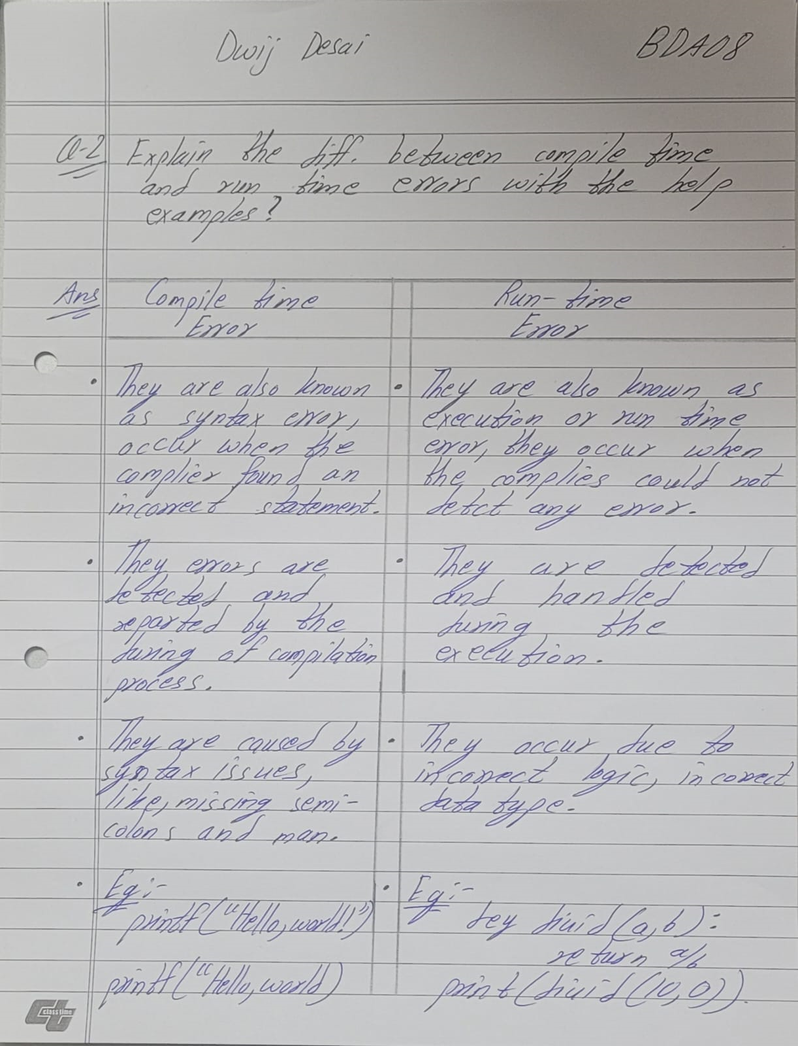

**Example of a compile-time error:**

int main() { int x = 5; printf("The value of y is %d\n", y); // Using an undeclared variable return 0; }

**Example of a run-time error:**

int main() { int a = 10; int b = 0; int result = a / b; // Division by zero printf("Result: %d\n", result); return 0; }

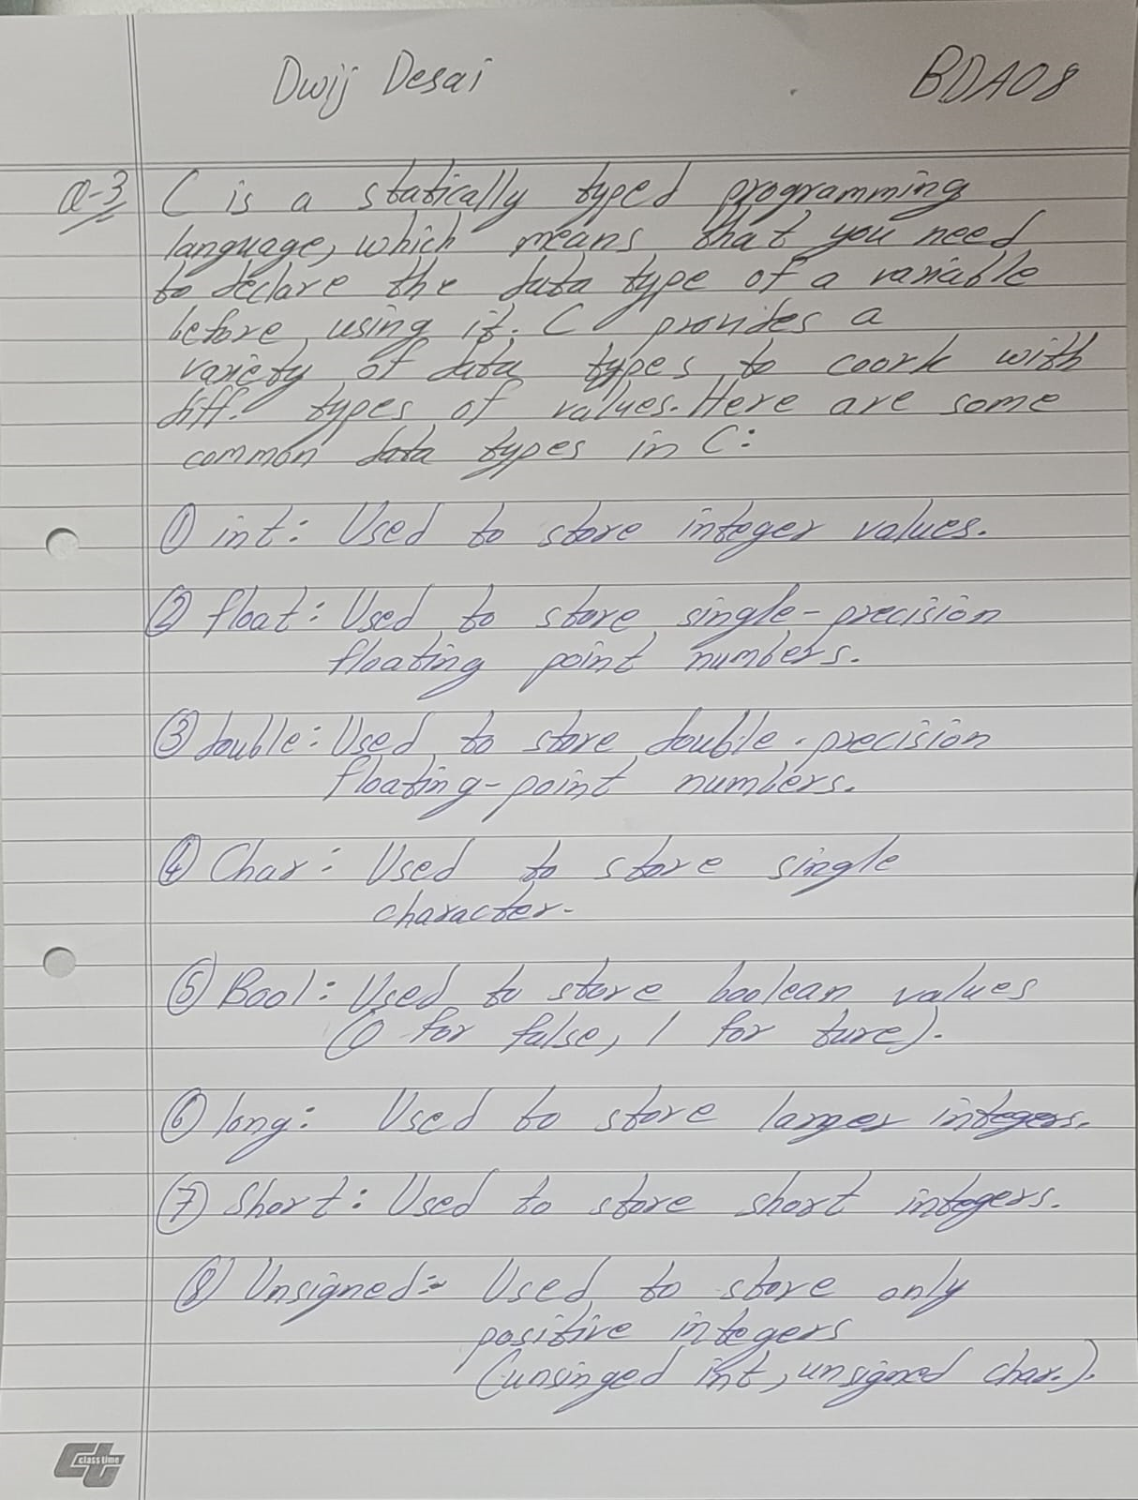

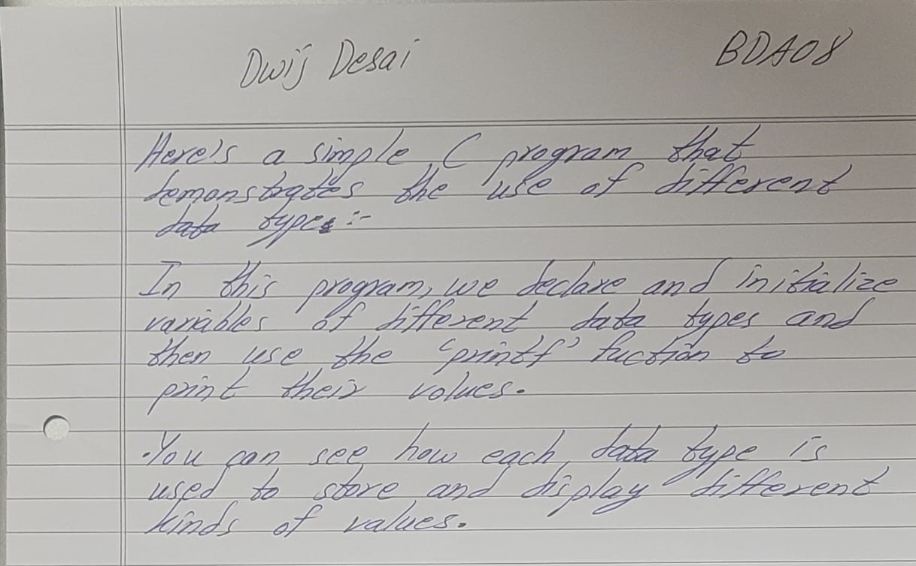

Here is an program for question 3:

#include <stdio.h>

int main() {

    int integerVar = 42;

    float floatVar = 3.1415;

    double doubleVar = 2.71828;

    char charVar = 'A';

    _Bool boolVar = 1; // true

    long longVar = 1234567890;

    short shortVar = 32767;

    unsigned int unsignedVar = 100;

    printf("int: %d\n", integerVar);

    printf("float: %f\n", floatVar);

    printf("double: %lf\n", doubleVar);

    printf("char: %c\n", charVar);

    printf("_Bool: %d\n", boolVar);

    printf("long: %ld\n", longVar);

    printf("short: %d\n", shortVar);

    printf("unsigned int: %u\n", unsignedVar);

    return 0;

}

**Question – 4:** Which variables below are syntactically correct?

**Answer:** This are the variables that are syntactically correct Num_var, var1 var2, v2 and I

The variables "10a," "float," "product’s," and "r.no" are not syntactically correct:

10a - Variable names cannot start with a digit. "10a" starts with a digit, making it an invalid variable name.

float - "float" is not a valid variable name because it is a reserved keyword in C and cannot be used as an identifier.

product’s - Variable names cannot contain special characters like apostrophes. "product’s" contains an apostrophe, which is not allowed.

r.no - Variable names cannot contain periods. "r.no" contains a period, which is not allowed in variable names.

**Question – 5:** What will happen if a variable is declared as constant? Give a program example for constant variable declaration.

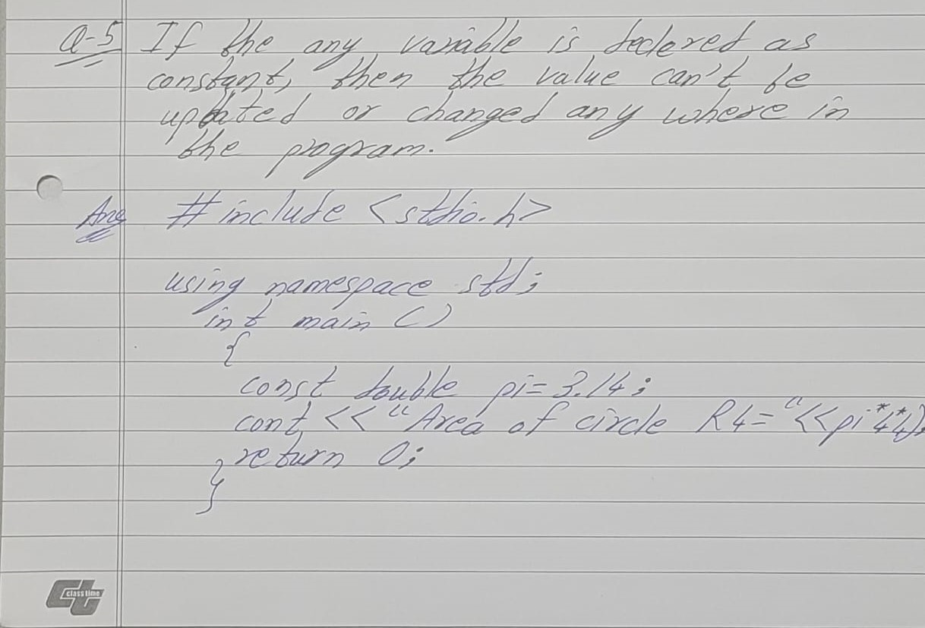

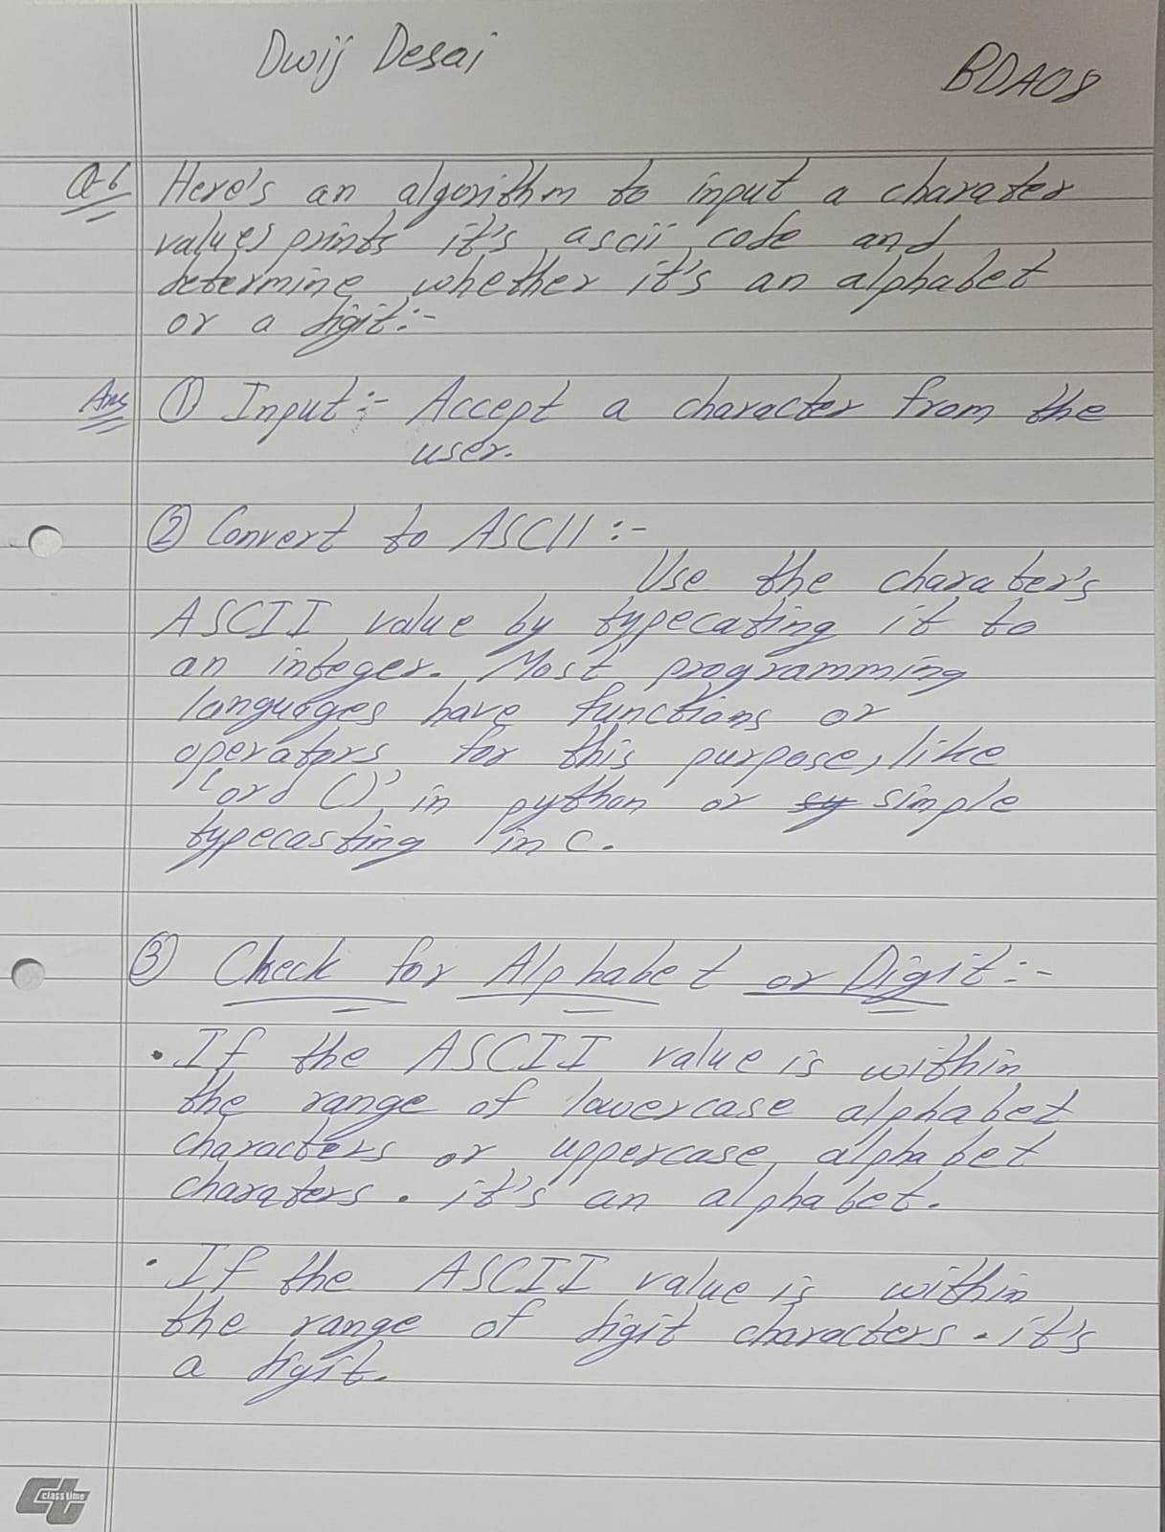

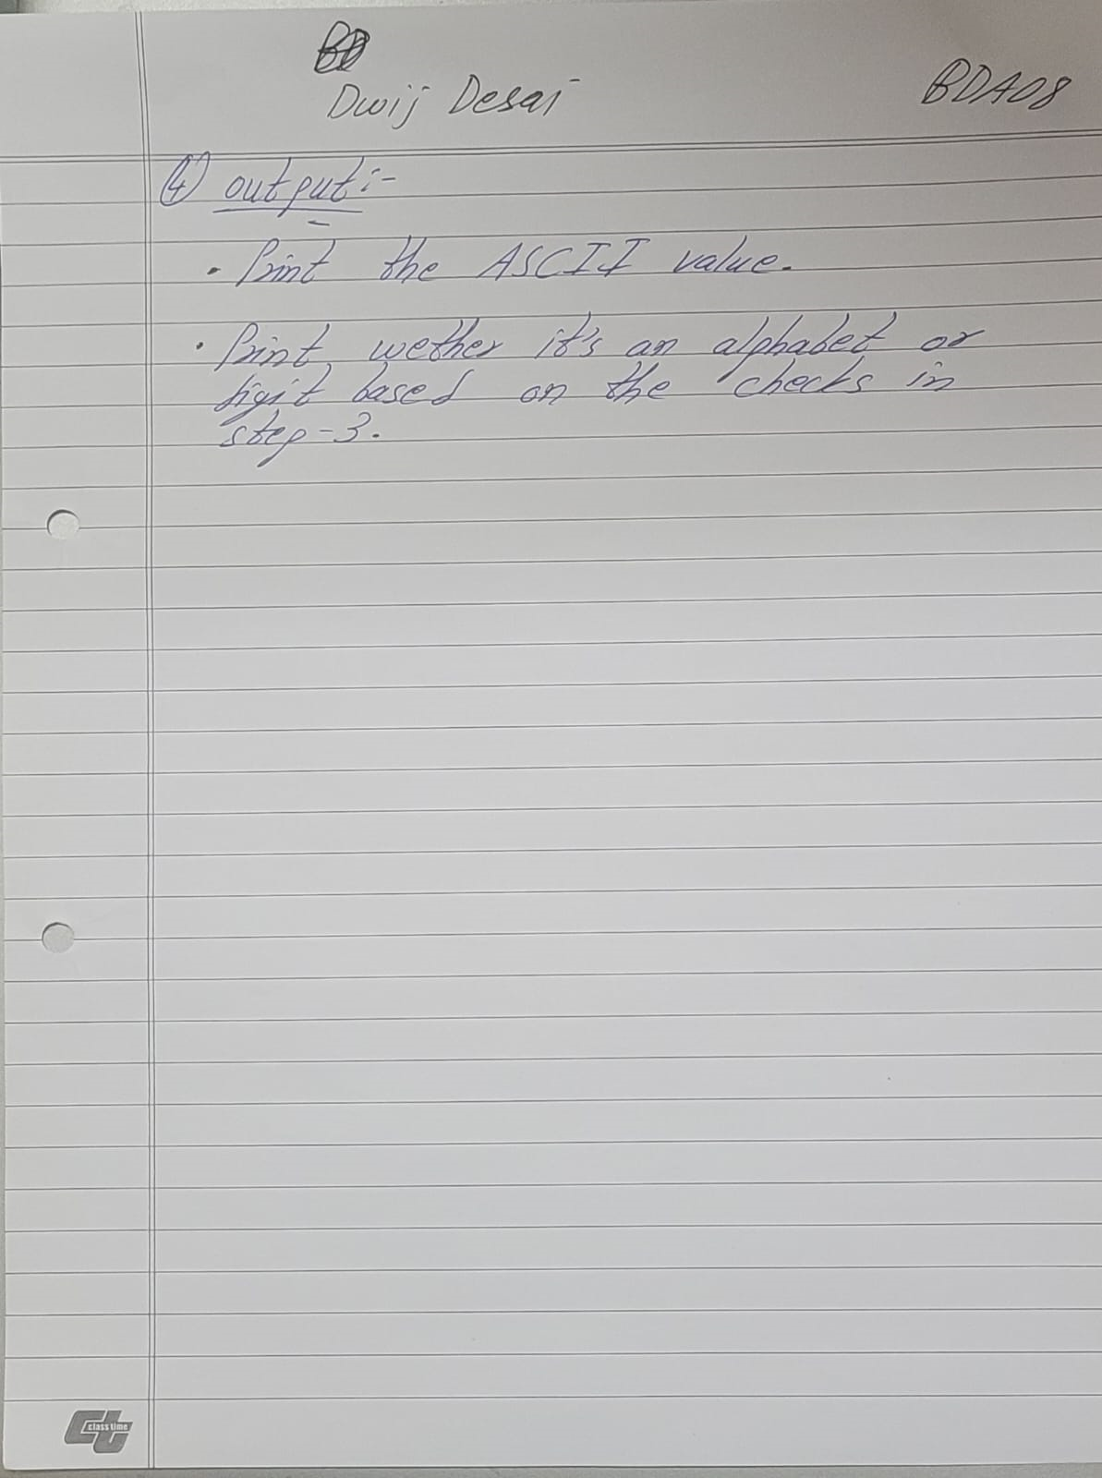

Example of using arithmetic operators:

#include <stdio.h>

int main() {

    int a = 10;

    int b = 5;

    int sum = a + b;

    int difference = a - b;

    int product = a * b;

    int quotient = a / b;

    int remainder = a % b;

    printf("Sum: %d\n", sum);

    printf("Difference: %d\n", difference);

    printf("Product: %d\n", product);

    printf("Quotient: %d\n", quotient);

    printf("Remainder: %d\n", remainder);

    return 0;

}

Example of using relational operators:

    #include <stdio.h>

int main() {

    int x = 5;

    int y = 10;

    if (x == y) {

        printf("x is equal to y.\n");

    } else {

        printf("x is not equal to y.\n");

    }

    if (x < y) {

        printf("x is less than y.\n");

    }

    return 0;

}

Example of using logical operators:

#include <stdio.h>

int main() {

    int a = 1;

    int b = 0;

    if (a && b) {

        printf("Both a and b are true.\n");

    }

    if (a || b) {

        printf("At least one of a or b is true.\n");

    }

    if (!b) {

        printf("b is false (negation).\n");

    }

    return 0;

}

Example of using assignment operators:

#include <stdio.h>

int main() {

    int x = 10;

    x += 5;  // Equivalent to x = x + 5;

    printf("x is now: %d\n", x);

    return 0;

}

**Question – 8:** Explain the concept if, if – else, nested if – else and else if ladder condition in c with the help of program example.

**Answer:**

conditional statements allow you to make decisions in your code based on certain conditions. There are four main types of conditional statements: if, if-else, nested if-else, and else-if ladder. Each of these statements serves a different purpose in controlling the flow of your program. Here's an explanation of each with program examples:

**if Statement:**

The if statement is the most basic form of a conditional statement. It allows you to execute a block of code if a given condition is true.

**if-else Statement:**

The if-else statement allows you to execute one block of code if the condition is true and another block of code if the condition is false.

**Nested if-else Statement:**

You can have if-else statements inside other if or else blocks. This is known as nesting, and it allows for more complex decision-making.

**else if Ladder:**

An else if ladder is used when you have multiple conditions to check, and you want to execute different code blocks based on which condition is true.

**Question – 9:**

What are the classifications of loops? Explain with the help of syntax, flowchart, and suitable program examples?

**Answer:** There are three main types of loops that are used to execute a block of code repeatedly based on a condition

**for loop:**

The for loop is used when you know the number of iterations in advance. It consists of three parts: initialization, condition, and increment/decrement. The loop runs as long as the condition is true.

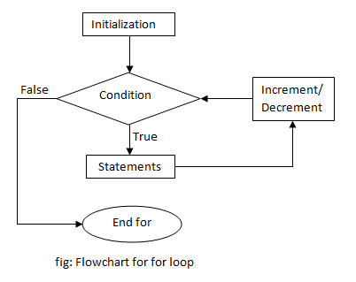

**while Loop:**

The while loop is used when you don't know the number of iterations in advance, and it runs as long as a given condition is true.

while (condition)

{

// code to be executed

}

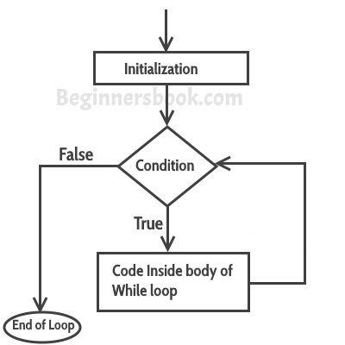

**do-while Loop:**

The do-while loop is similar to the while loop, but it guarantees that the code block is executed at least once. It checks the condition after executing the code block.

do

{

// code to be executed

} while (condition);

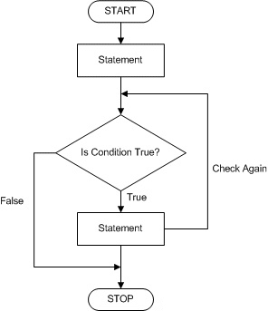

**Find Outputs of following programs:**

1.

*#include*<stdio.h>

int main ()

{

    int p=5;

    printf("%d",++(p));

*return* 0;

}

The code you provided contains a syntax error and won't compile successfully in C. The error is in the line ‘printf("%d",++(p)); ‘. The ‘(p) ‘ inside the ‘++ ‘ operator is incorrect; it should be ‘p ‘.

**Output:**6

2.

*#include*<stdio.h>

int main ()

{

    int i=10;

    i=!(i>14);

    printf ("i=%d",i);

*return* 0;

}

‘i = !i > 14; ‘: This line contains two issues:

- The ‘! ‘ operator is used to perform logical negation, which results in a boolean value of ‘0 ‘ (false) or ‘1 ‘ (true). In this context, it will treat ‘i ‘ as a boolean expression.

- The comparison ‘!i > 14 ‘ is likely not what you intended. It will evaluate to either ‘0 ‘ or ‘1 ‘ (depending on the value of ‘i ‘), which is then compared to ‘14 ‘.

3.

*#include*<stdio.h>

int main()

{

    int num =10;

    printf("%10d", num);

*return* 0;

}

‘printf("%10d", num); ‘: This line uses the ‘printf ‘ function to format and print the value of ‘num‘

. Here's the explanation:

- ‘printf ‘ is a function used for formatted output in C.  
 - ‘"%10d" ‘ is a format specifier:  
- ‘% ‘ indicates that a format specifier follows.  
- ‘10 ‘ specifies the field width. It means that the printed value should be right-aligned within a field  
of 10 characters.  
- ‘d ‘ specifies that the argument to be printed is an integer ( ‘num ‘ in this case).

4.

*#include*<stdio.h>

*#define* a 10

int main ()

{

    printf("%d",a);

*return* 0;

}

**Output:**10

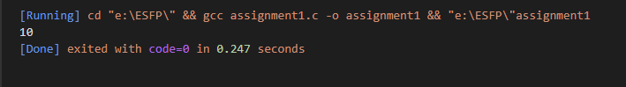

5.

*#include*<stdio.h>

int main ()

{

    int i=10,j=20;

    printf("%d..%d",i,j);

*return* 0;

}

**Output:**10..20

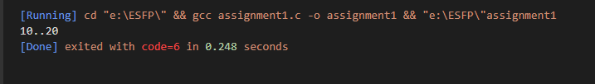

6.

*#include* <stdio.h>

int main()

{

    int i;

    printf("%d", scanf("%d", &i));

*return* 0;

}

7.

*#include* <stdio.h>

void main()

{

    char not;

    not = !2;

    printf("%d", not);

}

**Programing exercise :**

1.

*#include* <stdio.h>

int main()

{

    int num1, num2, num3, least;

    printf("Enter three integers: ");

    scanf("%d %d %d", &num1, &num2, &num3);

    least = (num1 < num2) ? ((num1 < num3) ? num1 : num3) : ((num2 < num3) ? num2 : num3);

    printf("The least number is: %d\n", least);

*return* 0;

}

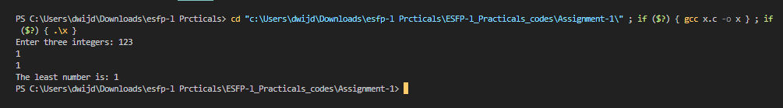

2.

*#include* <stdio.h>

int isPrime(int num)

{

*if* (num <= 1)

    {

*return* 0;

    }

*for* (int i = 2; i * i <= num; i++)

    {

*if* (num % i == 0)

        {

*return* 0;

        }

    }

*return* 1;

}

int isPerfect(int num)

{

    int sum = 0;

*for* (int i = 1; i <= num / 2; i++)

    {

*if* (num % i == 0)

        {

            sum += i;

        }

    }

*return* (sum == num);

}

int main()

{

    int num;

    printf("Enter a number: ");

    scanf("%d", &num);

*if* (num % 2 == 0)

    {

        printf("%d is even.\n", num);

    }

*else*

    {

        printf("%d is odd.\n", num);

    }

Jaymin Gondaliya  ESFP-I CS04

*if* (isPrime(num))

    {

        printf("%d is a prime number.\n", num);

    }

*else*

    {

        printf("%d is not a prime number.\n", num);

    }

*if* (isPerfect(num))

    {

        printf("%d is a perfect number.\n", num);

    }

*else*

    {

        printf("%d is not a perfect number.\n", num);

    }

*return* 0;

}

3.

*#include* <stdio.h>

int main()

{

    float tCharge, uCharge, tax;

    int unit;

    printf("Enter monthly electricity consumed units: ");

    scanf("%d", &unit);

*if* (unit >= 1 && unit <= 100)

    {

        uCharge = 5.0;

    }

*else* *if* (unit >= 101 && unit <= 200)

    {

        uCharge = 10.0;

    }

*else* *if* (unit >= 201 && unit <= 300)

    {

        uCharge = 15.0;

    }

*else*

    {

        uCharge = 20.0;

    }

    tCharge = unit * uCharge;

    tax = 0.05 * tCharge;

    tCharge += tax;

    printf("Total monthly electricity charge: Rs. %.2f\n", tCharge);

*return* 0;

}

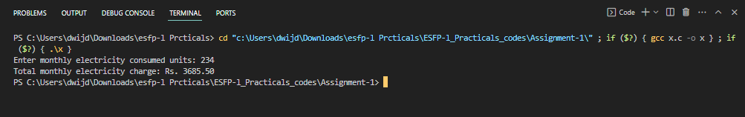

4.

#include <stdio.h>

int main()

{

    float bSalary,da, hra, others, pf, grossSalary, ma, netSalary;

    printf("Enter basic salary: Rs. ");

    scanf("%f", &bSalary);

    da=0.12*bSalary;

    hra=0.30*bSalary;

    others=1000.0;

    pf=0.12*bSalary;

    grossSalary=(bSalary + da + hra)-pf;

    ma = 0.05*bSalary;

    netSalary=grossSalary - ma;

    printf("Net Salary: Rs. %.2f\n", netSalary);

    return 0;

}

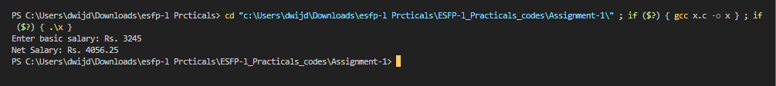

5.

*#include* <stdio.h>

int main()

{

    int num;

    int sum=0;

    int product=1;

    printf("Enter a five-digit number: ");

    scanf("%d", &num);

*if* (num < 10000 || num > 99999)

    {

        printf("Invalid input. Please enter a five-digit number.\n");

*return* 0;

    }

    int digit;

    int alternate = 1;

*while* (num > 0)

    {

        digit = num % 10;

*if* (alternate)

        {

            product *= digit;

        }

*else*

        {

            sum += digit;

        }

        alternate = 1 - alternate;

        num /= 10;

    }

    printf("Multiplication = %d\n", product);

    printf("Addition = %d\n", sum);

*return* 0;

}

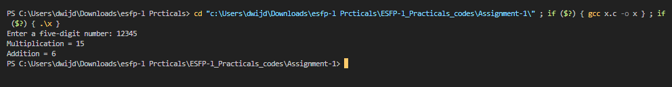

6.

*#include* <stdio.h>

int main()

{

    int i, j, k;

*for* (i = 6; i >0; i--)

    {

        char ch = 'A';

*for* (j = 0; j < i; j++)

        {

            printf("%c", ch);

            ch++;

        }

*for* (k = 0; k < 2*(6 - i); k++)

        {

            printf(" ");

        }

        ch--;

*for* (j = 0; j < i; j++)

        {

            printf("%c", ch);

            ch--;

        }

        printf("\n");

    }

    printf("\n");

*for* (i = 0; i < 5; i++)

    {

*for*(j=0;j<i;j++)

        {

            printf(" ");

        }

*for* (j = 0; j < 9 - 2 * i; j++)

        {

            printf("*");

        }

        printf("\n");

    }

*return* 0;

}

